**Project Design Phase-II**

**Data Flow Diagram & User Stories**

|  |  |
| --- | --- |
| Date | 17 October 2022 |
| Team ID | PNT2022TMID50490 |
| Project Name | Project – News Tracker Application |
| Maximum Marks | 4 Marks |

**Data Flow Diagrams:**

A Data Flow Diagram (DFD) is a traditional visual representation of the information flows within a system. A neat and clear DFD can depict the right amount of the system requirement graphically. It shows how data enters and leaves the system, what changes the information, and where data is stored.

**Example:** [**(Simplified)**](https://developer.ibm.com/patterns/visualize-unstructured-text/)

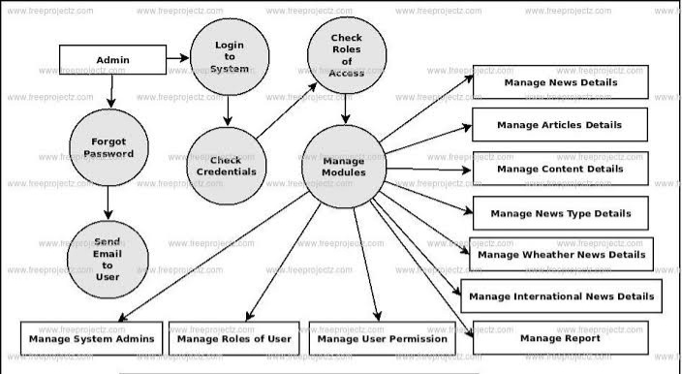

**User Stories**

Use the below template to list all the user stories for the product.

| **User Type** | **Functional Requirement (Epic)** | **User Story Number** | **User Story / Task** | **Acceptance criteria** | **Priority** | **Release** |
| --- | --- | --- | --- | --- | --- | --- |
| Customer (Mobile user) | Registration | USN-1 | As a user, I can register for the application by entering my email, password, and confirming my password. | I can access my account / dashboard | High | Sprint-1 |
|  | Confirmation | USN-2 | As a user, I will receive confirmation email once I have registered for the application | I can receive confirmation email & click confirm | High | Sprint-1 |
|  | Linked Through Facebook | USN-3 | As a user, I can register for the application through Facebook | I can register & access the dashboard with Facebook Login | Low | Sprint-2 |
|  | Linked Through Gmail | USN-4 | As a user, I can register for the application through Gmail | I can login through gmail verification | Medium | Sprint-3 |
|  | Login | USN-5 | As a user, I can log into the application by entering email & password | I can access the app by verifying my account | High | Sprint-1 |
|  | Dashboard | USN-6 | Followers, following, post, views, comments, shares, likes. | I can see it with the support of log in | High | Sprint-1 |
| Customer (Web user) | App users | USN-7 | An individual user who is authorized by the customer to use the web form of the work wide technology. | I can accept the customer with the user details | Medium | Sprint-3 |
| Customer Care Executive | App executor | USN-8 | An executor performs a number of duties, including answering phones, responding to customer questions and assisting with customer issues. | App executors will login through their id confirmation. | High | Sprint-1 |
| Administrator | App admin | USN-9 | Administrators support the smooth running of office by carrying out clerical tasks and project. | Admin can log in through admin verification | High | Sprint-1 |